**Bug reports on the site** [**https://qahacking.guru/**](https://qahacking.guru/)

**Title**: In the "Pet Reservation Form" the "Special Requests" window is not active.

**Environment:** Google Chrome, Windows 10

**Steps to reproduce:**

The user:

* is on the "About Us" page (https://qahacking.guru/index.php/about)
* Scrolls down to "Pet Reservation Form
* Clicks on the "Special Requests" box

**Expected Result**: The user enters information from the keyboard. Element was created by the “Input".

**Actual Result**: unit is not active. No possibility to enter data from the keyboard. Element was created by the "Label".

**Visual Proof (screenshots, videos, text):** https://qahacking.guru/index.php/about

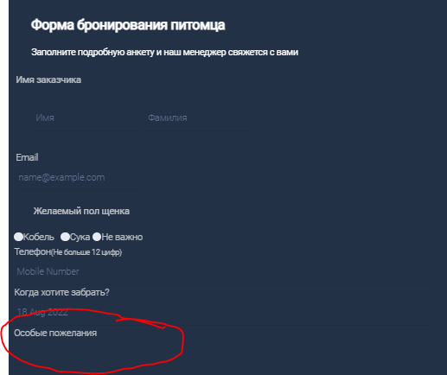

**Severity:** major

**Priority**:medium